Lab: ZAp and dvwa

I downloaded ZAP from the official download page and proceeded to install and configure it according to the provided instructions

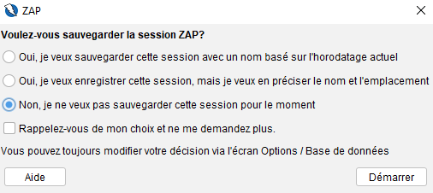

I downloaded Damn Vulnerable Web App (DVWA) using Docker, installed it from the download page, and successfully ran it on my Windows environment.I did that using docker desktop.
Here are the steps of docker’s configuration:

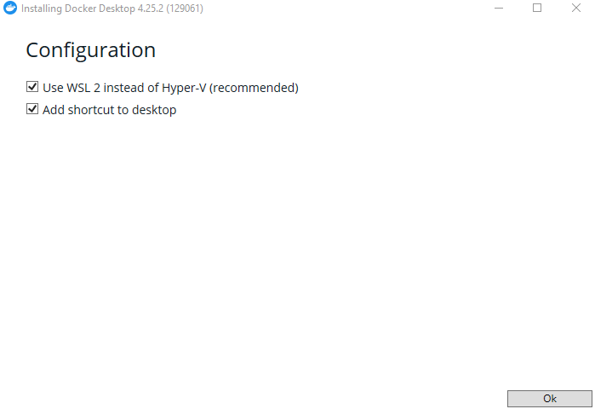
figure:configuration
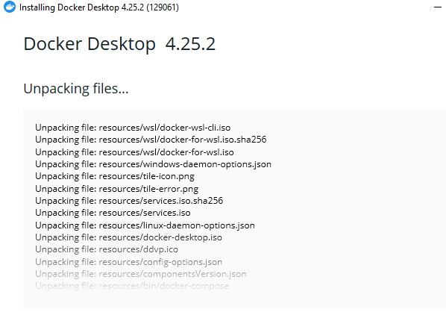
figure:packages

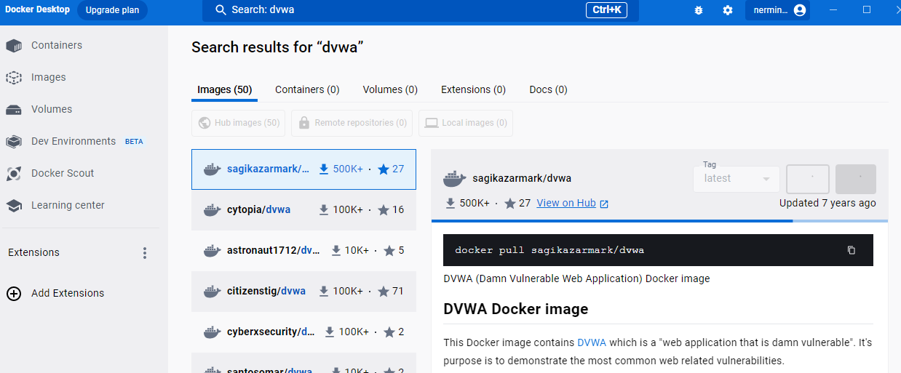

figure:searching dvwa docker image

I clicked on pull after that I wrote localhost:3306 on the navigator
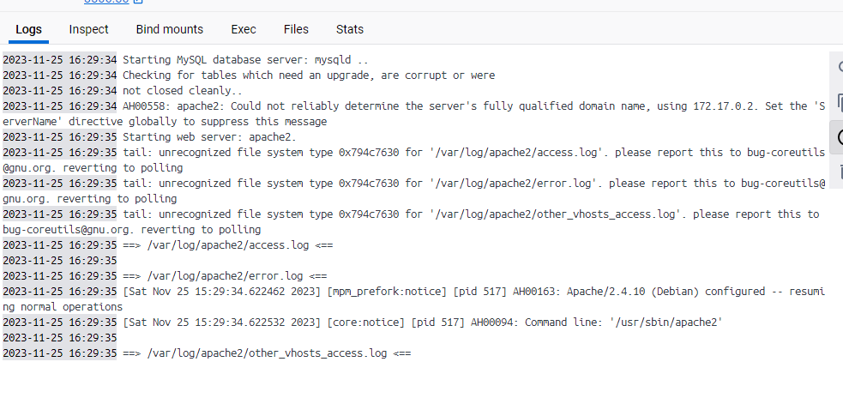l

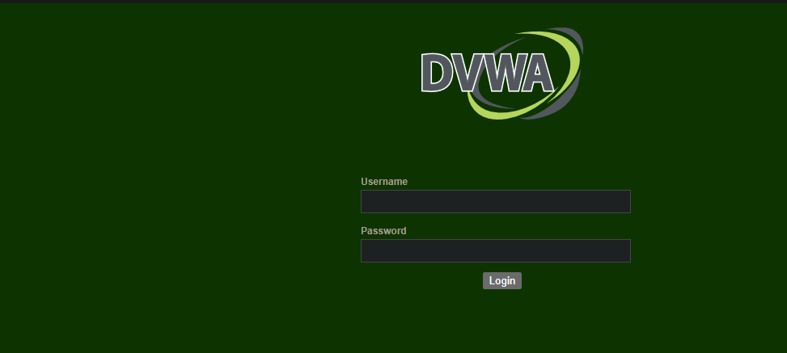
figure:Dvwa
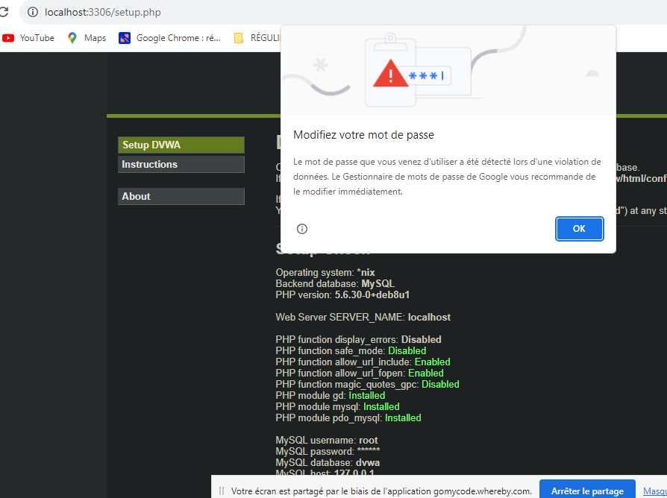l
I wrote username and password :admin
I started the automated scan on localhost :3306
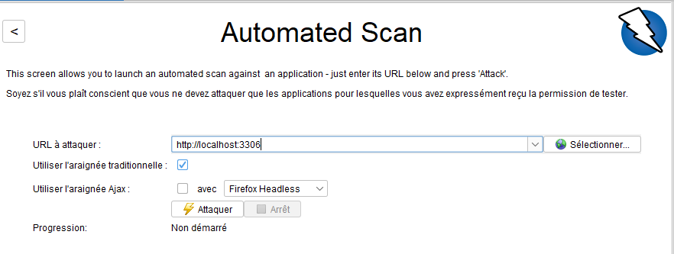
The result of the scanning:
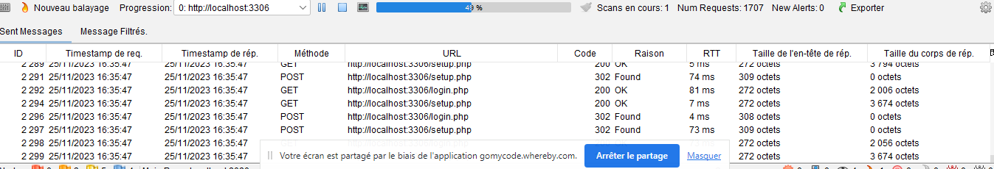
Examples of vulnerabilities
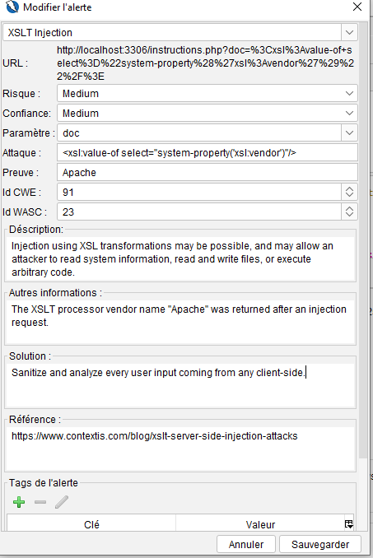

During a security analysis of the DVWA (Damn Vulnerable Web Application) using OWASP ZAP (Zed Attack Proxy), a potential XSLT Injection vulnerability was identified.
XSLT (eXtensible Stylesheet Language Transformations) is a language used for transforming and presenting XML documents. In the context of web applications, XSLT Injection occurs when an attacker is able to inject malicious XSLT code into an input field or parameter that is processed by an XSLT processor on the server.
The identified vulnerability suggests that the injection of XSLT transformations might be possible in the analyzed DVWA. If successfully exploited, this could allow an attacker to perform various malicious actions, such as:
- Reading System Information: The attacker may be able to retrieve information about the system running the web application.
- Reading and Writing Files: Depending on the permissions of the web application, the attacker might be able to read or even write files on the server.
- Executing Arbitrary Code: In some cases, successful XSLT Injection may enable the execution of arbitrary code on the server, giving the attacker significant control over the system.
Additionally, the information about the XSLT processor vendor name "Apache" being returned after an injection request indicates that the web application is likely using an Apache XSLT processor. This information might be useful for the attacker in crafting more specific and targeted exploits.
To mitigate this vulnerability, it is recommended to validate and sanitize user input properly, especially when dealing with XML or XSLT transformations. Additionally, implementing proper access controls and security mechanisms can help protect against XSLT Injection attacks.
Other vulnerability:

Cookie without HttpOnly Flag:
When a web server sets a cookie, it can include various attributes that define how the cookie should behave. One such attribute is the HttpOnly flag. When this flag is present, it instructs the browser that the cookie should not be accessible through client-side scripts, particularly JavaScript. The purpose of the HttpOnly flag is to enhance security by preventing certain types of attacks, such as Cross-Site Scripting (XSS).
Implications of Missing HttpOnly Flag:
If a cookie is set without the HttpOnly flag, it means that client-side scripts, including JavaScript, have the ability to access and manipulate the contents of that cookie. This can introduce security risks, especially if there is a malicious script running on the same page.
Possible Consequences:
- Script Access: If an attacker manages to inject a malicious script into the web page, either through a vulnerability like XSS or other means, that script can access the cookie information.
- Exfiltration of Cookie Data: Once the cookie is accessible via JavaScript, an attacker can potentially exfiltrate its data, meaning they can retrieve the cookie's content and send it to another site under their control.
- Session Hijacking: If the cookie in question is a session cookie (used for session management and user authentication), the risk is particularly high. An attacker could hijack a user's session by stealing their session cookie, gaining unauthorized access to the user's account.
Mitigation:
The recommended mitigation for this vulnerability is to ensure that sensitive cookies, especially those related to authentication and sessions, include the HttpOnly flag. This can be configured on the server side when setting the cookie. By doing so, even if a page has a script injection vulnerability, the cookie remains inaccessible to JavaScript, reducing the risk of unauthorized access and session hijacking.
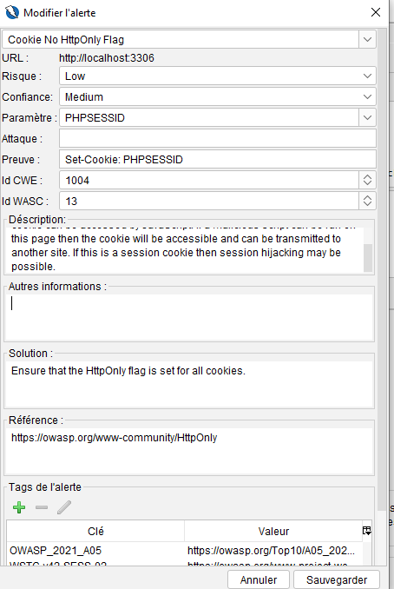

Other vulnerability:

X-Content-Type-Options Header:
The "X-Content-Type-Options" is an HTTP response header that helps to mitigate certain types of attacks related to MIME (Multipurpose Internet Mail Extensions) types. MIME types indicate the nature and format of a document or file.
'nosniff' Directive:
The 'nosniff' directive is a specific value that can be set for the "X-Content-Type-Options" header. When this directive is present, it instructs the browser not to perform MIME-sniffing on the response body.
MIME-sniffing:
MIME-sniffing, or content sniffing, is a browser behavior where it tries to interpret the type of content delivered by a server based on the content itself rather than relying solely on the declared MIME type provided by the server. This behavior can lead to security issues if the browser interprets the content differently than intended by the server.
Explanation of the Vulnerability:
The vulnerability mentioned states that the "X-Content-Type-Options" header with the 'nosniff' directive is missing. This means that browsers, particularly older versions of Internet Explorer and Chrome, might perform MIME-sniffing on the response body.
Potential Consequences:
If MIME-sniffing occurs, the browser might interpret the response body as a content type other than the one declared by the server. This can lead to various security concerns, such as:
- Security Risks: MIME-sniffing can potentially introduce security risks, especially if the browser interprets the content in a way that could be exploited by attackers.
- Content Discrepancy: The browser may display or process the content differently than intended by the server, leading to potential discrepancies in how the content is presented to the user.
Mitigation:
To mitigate this vulnerability, web developers and administrators should ensure that the "X-Content-Type-Options" header is set with the 'nosniff' directive. This helps enforce the declared content type provided by the server, preventing browsers from attempting MIME-sniffing and improving security by avoiding potential misinterpretations of content.

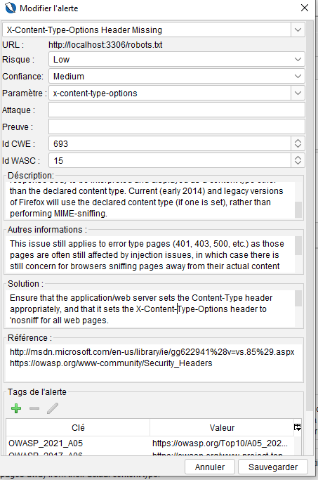

Designing a secure hosting architecture based on the Defense in Depth (DiD) principle involves implementing multiple layers of security to protect your web application. Here's a draft architecture:
- Web Application Firewall (WAF):
  - Deploy a WAF to inspect and filter HTTP traffic between a web application and the Internet. It helps protect against various web application attacks, including SQL injection, cross-site scripting (XSS), and other OWASP Top Ten vulnerabilities.
- Network Security:
  - Implement a Next-Generation Firewall (NGFW) to control and monitor network traffic. This includes features such as intrusion prevention, application layer filtering, and VPN support to secure network communication.
- Endpoint Detection and Response (EDR):
  - Utilize EDR solutions on endpoints to detect and respond to advanced threats. EDR systems monitor endpoint activities, detect malicious behavior, and provide real-time response capabilities to mitigate potential threats.
- Secure Access Controls:
  - Enforce strict access controls and least privilege principles. Implement role-based access control (RBAC) for users, applications, and services. Use multi-factor authentication (MFA) to enhance user authentication.
- Secure Web Hosting Platform:
  - Choose a secure and reputable hosting platform. Ensure that the underlying infrastructure is regularly patched and updated to address any security vulnerabilities.
- Data Encryption:
  - Implement encryption for data in transit (SSL/TLS) and data at rest. Use strong encryption algorithms to protect sensitive information.
- Logging and Monitoring:
  - Set up comprehensive logging and monitoring systems to track and analyze security events. Implement Security Information and Event Management (SIEM) solutions to correlate logs and provide real-time insights.
- Incident Response Plan:
  - Develop and regularly test an incident response plan. This plan should outline procedures to follow in case of a security incident, including communication, containment, eradication, recovery, and lessons learned.
- Regular Security Audits and Penetration Testing:
  - Conduct regular security audits and penetration testing to identify and address vulnerabilities in the system. This proactive approach helps ensure ongoing security.
- Backup and Disaster Recovery:
  - Implement a robust backup and disaster recovery strategy. Regularly back up critical data and test the restoration process to ensure business continuity in case of data loss or system failure.
- Third-Party Security Assessments:
  - Regularly assess the security posture of third-party components, services, and dependencies. This includes evaluating the security practices of vendors and ensuring they adhere to security standards.
- User Education and Awareness:
  - Educate users and staff about security best practices. Training can help prevent social engineering attacks and enhance overall security awareness.

